Jiaqiang Guo

CS5150

[guo.jiaqia@husky.neu.edu](mailto:guo.jiaqia@husky.neu.edu)

Description of the Implement of the Opposing Player AI for *Clash Royale*

The opposing player AI is of great importance in current video games, and there are many of designers, computer scientists and even physicians contribute to the evolution of the opposing player AI. As far as my perspective, the goal of building an opposing player AI is to provide a good game experience for players so the opposing player AI should match the skill of players. A too stupid AI system and an invulnerable AI system will both ruin the experience of the players. In my implement of the opposing player AI, I implement reasonable strategies based on the player’s strategies and avoid stupid deployments of mobs. For example, the AI system never use a Giant to combat with an enemy Giant, and swordsman should place near an archer to take advantage. Meantime, a skillful and observant player can find the regulation of the strategies in my opposing AI and the weakness of the AI system so the player can use their strategies to overcome the AI system and win the game.

The overall structure of my AI system is utility-based decision-making system.

The decision-making process mainly include the steps below:

1. Choose overall strategy based on the elixirs and there is nor not enemy mobs.

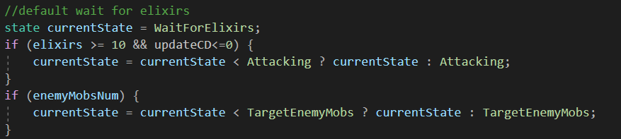

1. Getting information of the enemy Mobs and towers.
2. Calculating the Utility Score of each enemy mob based on the information.



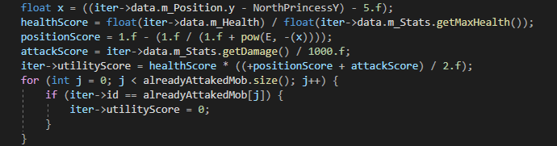

1. Comparing the Utility Score and find the most prioritized enemy mob that the AI have to first address.
2. More information is calculated to form more combating strategies for this most prioritized mob.

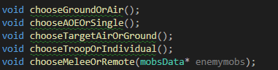

1. Search the current card pool to find the mob most suitable for combating this mob based on the combating strategy.



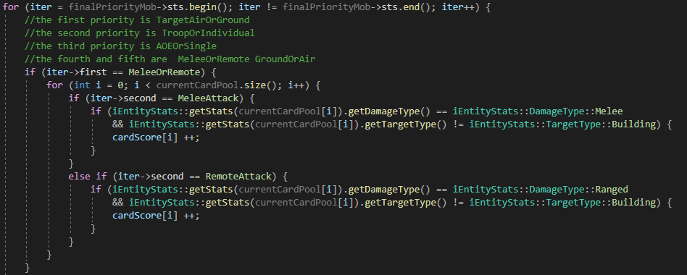

1. Checking whether or not this mob need another mob to combat with the enemy mob together.



1. Place the mob or mobs.

Now there are only ground mobs and the mobs that are the single damage type, so I only need to consider the melee and remote, and attacking buildings and attacking any. However, I deeply consider if there are more and more types of card, how to deal with these new cards in my AI system. In this AI system, if new cards are added into the game, new function of calculate Utility Score are added into the code. and through comparing the score, the UI system can make the relatively best decision.

There is a speaker system that my AI system can tell the player what happened, what decision the AI system made, and why the AI system make this decision.



In the end, this AI system also has many aspects have to be improve, for example, how to expand the advantage, how to use the spell card, how to provide more various strategies and so on. However, in present, the AI system can avoid most of stupid situations and build a rival with good play experience.